**2731 - Coco-Bits and the Well**

**Description**

The Coco-Bits are building a circular shaped pit, to do so, they take a square and they draw an inscribed circle in it.

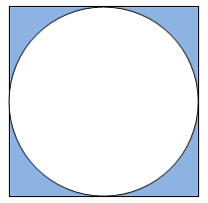

They want to determine the surface enclosed between the circle and the square. Can you help them?

**Input specification**

A line containing the number of cases T (1 <= T <= 100).

Each of the following T lines will contain the size of the side (1 <= L <= 100) of the square.

**Output specification**

Each of the T lines will contain the area requested for each case, rounded up to two decimals places.

**Sample input**

3  
20  
30.091  
87.0921

**Sample output**

85.84  
194.32  
1627.76

**Hint(s)**

|  |  |
| --- | --- |
| Statistics | **sub:**[305](http://coj.uci.cu/24h/status.xhtml?abb=2731)| **ac:**[142](http://coj.uci.cu/24h/status.xhtml?abb=2731&status=ac)|**ac%:** 46,56 |**score:** 1,20 |
| Created by | Jorge Bárbaro Piñeiro Cruz |
| Added by | [jbpineiro](http://coj.uci.cu/user/useraccount.xhtml?username=jbpineiro) |
| Addition date | 2014-03-04 |
| Time limit (ms) | 1000 |
| Memory limit (kb) | 130000 |
| Output limit (mb) | 64 |
| Size limit (bytes) | 15000 |
| Enabled languages | Bash | C | C# | C++ | Java | Pascal | Perl | PHP | Python | Ruby | Text |